Step 1: Set Up the Component
First, we need to create a functional component. In React, we typically use hooks like useState and useEffect to manage state and side effects.
Step 2: Define State Variables
We'll need state variables for the search input, the list of movies, and the sorting option.
Step 3: Fetch Movies
We'll create a function to fetch movies based on the search query and sort them accordingly.
Step 4: Render the Component
Finally, we'll render the input fields and the list of movies.
Here's how you can convert your code into a React component:
jsx
Copy the following code:
import React, { useState, useEffect } from 'react';
const MovieSearch = () => {
const apiEndpoint = "https://www.omdbapi.com/?apikey=b2cff54a";
const [searchQuery, setSearchQuery] = useState('');
const [sortBy, setSortBy] = useState('title');
const [movies, setMovies] = useState([]);
const [error, setError] = useState('');

const getMovies = async (query) => {
try {
const response = await fetch(`${apiEndpoint}&s=${encodeURIComponent(query)}`);
if (!response.ok) {
throw new Error(`HTTP error! status: ${response.status}`);
}
const data = await response.json();
return data;
} catch (err) {
setError(err.message);
}
};

const displayMovies = async () => {
if (searchQuery) {
const payload = await getMovies(searchQuery);
if (!payload || !payload.Search) {
setMovies([]);
setError("No movies found.");
return;
}
const sortedMovies = payload.Search.sort((a, b) => {
return sortBy === 'year' ? b.Year - a.Year : a.Title.localeCompare(b.Title);
});
setMovies(sortedMovies);
}
};

useEffect(() => {
displayMovies();
}, [searchQuery, sortBy]); // Re-run when searchQuery or sortBy changes

return (
<div>
<input
type="text"
id="search"
value={searchQuery}
onChange={(e) => setSearchQuery(e.target.value)}
placeholder="Search for movies..."
/>
<select id="sort" value={sortBy} onChange={(e) => setSortBy(e.target.value)}>
<option value="title">Sort by Title</option>
<option value="year">Sort by Year</option>
</select>

{error && <p>{error}</p>}
<div id="search-input">
{movies.map((movie) => (
<div className="container" key={movie.imdbID}>
<p>Title: {movie.Title}</p>
<p>Year: {movie.Year}</p>
<p>ImdbID: {movie.imdbID}</p>
<p>Type: {movie.Type}</p>
<p>Poster: <img src={movie.Poster} alt={movie.Title} /></p>
</div>
))}
</div>
</div>
);
};
export default MovieSearch;
Explanation:
- State Management: We use useState to manage searchQuery, sortBy, movies, and error.
- Fetching Movies: The getMovies function fetches data from the API and handles errors.
- Displaying Movies: The displayMovies function sorts and sets the movies based on the search query and selected sort option.
- Effect Hook: The useEffect hook runs displayMovies whenever searchQuery or sortBy changes.
- Rendering: We render an input for the search query, a dropdown for sorting, and a list of movie results.
Next Steps:
- Make sure to import and use this component in your main application file. (see Step1, 2, .. below)
- Test the functionality to ensure everything works as expected.

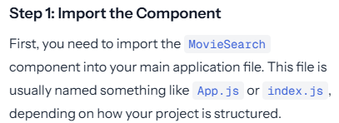
(see Step1, 2, .. below)

// Assuming MovieSearch.js is in the same directory as App.js
import MovieSearch from './MovieSearch';

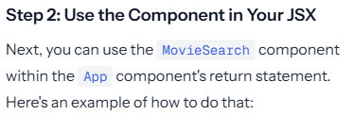

import React from 'react';
import MovieSearch from './MovieSearch'; // Import the MovieSearch component

const App = () => {
return (
<div>
<h1>Movie Search App</h1>
<MovieSearch /> {/* Use the MovieSearch component here */}
</div>
);
};

export default App;
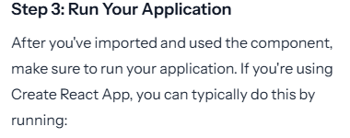
npm start (in bash)

Importing the MovieSearch component
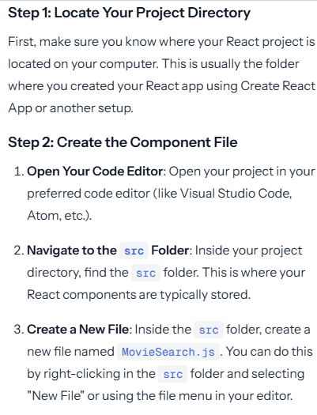
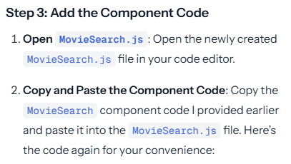
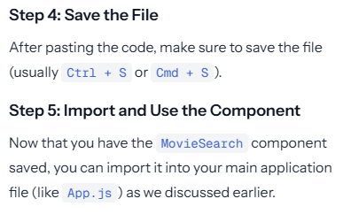

To import your MovieSearch component into your main application file (usually App.js)
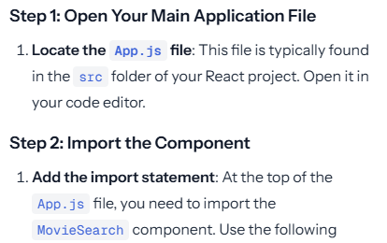
import MovieSearch from './MovieSearch'; // Adjust the path if MovieSearch.js is in a different folder
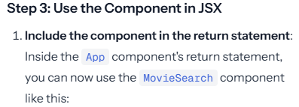
const App = () => {
return (
<div>
<h1>Movie Search App</h1>
<MovieSearch /> {/* This is where you include the MovieSearch component */}
</div>
);
};

